Help Validate Timed Acupressure for Jet Lag
© 2026 Steven Schram PhD, DC, LAc

Introduction
Jet lag affects many international travelers. Common strategies such as sunrise viewing, strategic melatonin use, sleep strategy and meal scheduling help some people but not all.¹ Acupuncturists have long proposed a different approach.

Nearly 50 years ago, Khoe² and then Amaro in 2001³ suggested that stimulating horary points based on destination time during travel might help the body adjust before arrival. Case reports and theorysupport the ide but no formal study has tested real travelers. We built an app that gives a 24-hour schedule of timed acupressure points (no needles)to use during travel.

If you plan international travel we invite you to try the app and, if you choose, join the research.

Circadian Biology and the Western Understanding of our Internal Clocks
Research shows that circadian rhythms align body processes to a roughly 24 hour cycle. The suprachiasmatic nucleus (SCN), in the brain acts as the master clock and light is the main signal.^{4,5} The SCN helps coordinate “peripheral clocks” in organs such as the liver and heart, including effects on blood vessels and pressure.^{6,7} Clock genes run a feedback loop that creates daily rhythms in gene activity.⁸ Zeitgebers, which are external cues such as light, temperature, activity, and meals, help keep these rhythms on track. ⁹

Jet lag happens when fast travel across time zone changes throws these clocks out of sync.

A 2024 review shows that acupuncture can affect circadian biology, including clock genes, neurotransmitters, and sleep-wake cycles.¹⁰ These studies used sleep related points, but they support a broader idea: acupuncture may act as a non-photic zeitgeber providing a cue that can shift rhythms without bright light.

In TCM, each meridian has a two-hour window when its related organ system is most active. The app knows the local time at your destination and it guides you to stimulate the meridian that would be active if you were already at your arrival city. Figure 1 shows this daily organ clock.

The idea is to give the body repeated cues aligned to the new time zone while you travel.

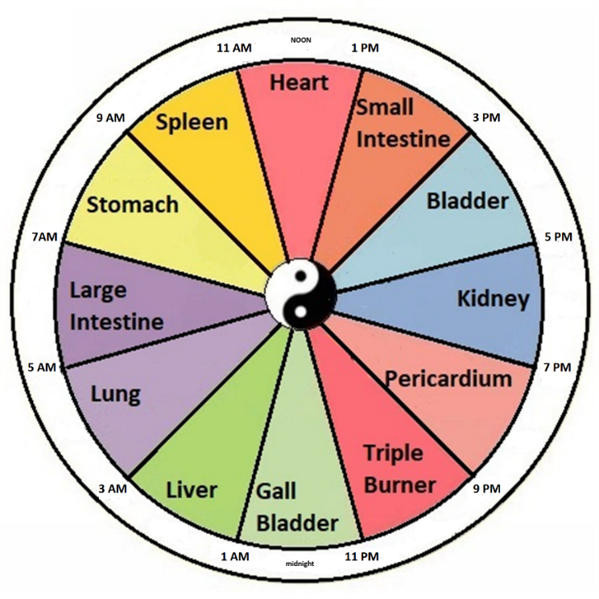
Figure 1: 24-hour Organ Clock

Table 1: 24-hour Schedule
Time Range | Meridian / Organ System | Horary -> Suggested Point
3:00 AM – 5:00 AM | Lung | LU-8
5:00 AM – 7:00 AM | Large Intestine | LI-1
7:00 AM – 9:00 AM | Stomach | ST-36
9:00 AM – 11:00 AM | Spleen | SP-3 -> SP-10*
11:00 AM – 1:00 PM | Heart | HT-8
1:00 PM – 3:00 PM | Small Intestine | SI-5
3:00 PM – 5:00 PM | Bladder | BL-66 -> BL-2*
5:00 PM – 7:00 PM | Kidney | KI-10 -> KI-27*
7:00 PM – 9:00 PM | Pericardium | PC-8
9:00 PM – 11:00 PM | San Jiao (Triple Warmer) | SJ-6
11:00 PM – 1:00 AM | Gallbladder | GB-41 -> GB-20*
1:00 AM – 3:00 AM | Liver | LIV-1 -> LIV-8*
Table 1
The * suggested points are modifications implemented for practical accessibility.

Point Changes for Practical Accessibility
While Amaro recommended the actual horary points on each meridian. But early testers flying economy class often did not want to remove their shoes to reach the ankle and foot points. We substituted easier to reach points o on the same channel thinking it would be better than skipping that time window altogether.

For easier location, we chose to use SP-10 for SP-3, BL-2 for BL-66, GB-20 for GB-41, LIV-8 for LIV-1, and KI-27 for KI-10. In TCM, stimulating any point on a meridian can influence the whole channel so these swaps keep the same meridian timing while improving access.

How to participate

On your iPhone, get the appat https://jetlagpro.com/#download. The website has step-by-stepinstructions. . The app is entirely free with no add-ons, upgrades or ads. After install, follow the in-app directions for timing and instructions. If you have questions, email us info@jetlagpro.com.

Research in plain terms: After a qualifying trip, the app shows an informed-consent screen. Tap Share to send anonymous trip data, or Not now to skip. If you tap Share, the app reminds you about a short symptom survey about two days later.

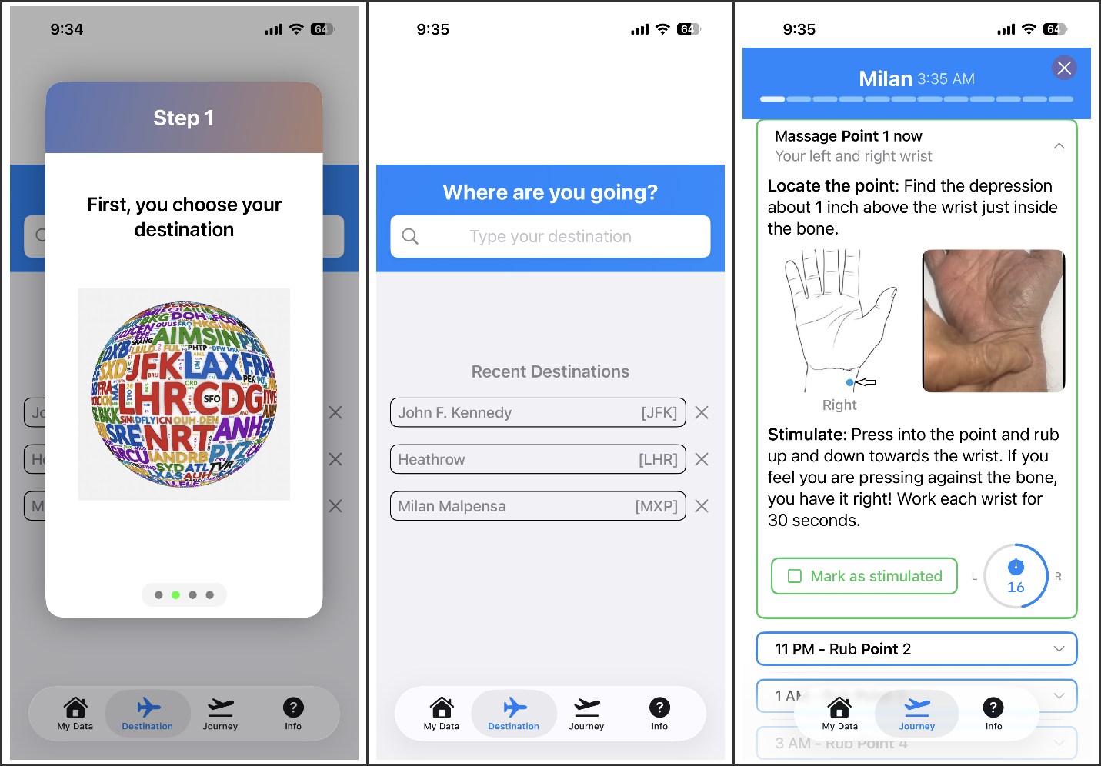

Figure 2 – The Three Steps

Scheduled reminders pop up over the next 24 hours to prompt the traveler to do the next point. The reminders are persistent and remain on the user's phone (or Apple Watch) until tapped. When tapped, the traveler is shown the correct point image beside a looping video showing how to stimulate the point.

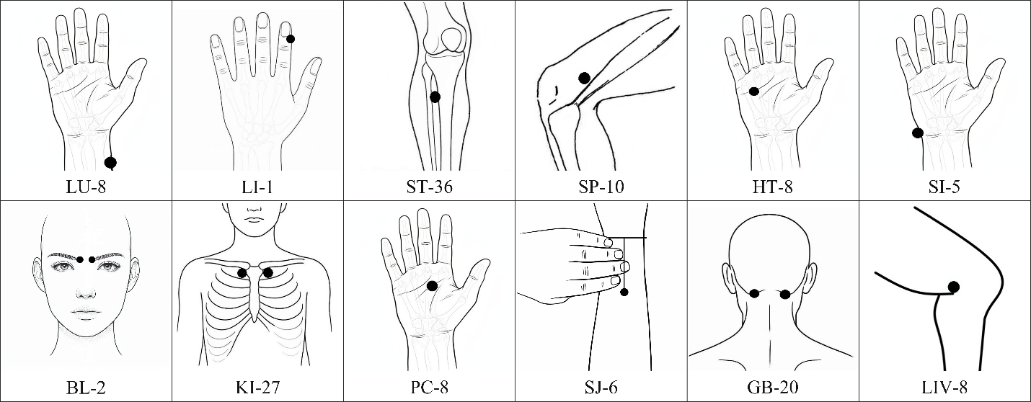

Figure 3 – Point Images

After the trip ends, the app saves point stimulation data along with origin and arrival time zones to a central database. Then a survey reminder is scheduled for 2 days later. This survey is a streamlined assessment based on the Liverpool Jet Lag Questionnaire's core symptom domains.

Data Analysis
Our main question: Is greater use of the scheduled acupressure points associated with lower reported jet lag symptoms in real travelers? We will compare survey answers to expected severity by time zones crossed, using Waterhouse et al (2007) as a reference¹. We will group trips by how many acupressure points were stimulated and how many time zones were crossed. This is an observational study is pre-registered at Open Science Framework: osf.io/jm4w7.

Discussion
Controlled jet lag trials face are hard because each trip differs in terms of sleep, light, caffeine, health, and environment . This observational study works with that reality. We ask whether more point use is associated with symptom reports in real travel. We are not asking if the app proves a treatment effect. We aim for roughly 500 qualifying trips so we can describe patterns with reasonable precision.

References
- Waterhouse, J., Reilly, T., Atkinson, G., & Edwards, B. (2007). Jet lag: Trends and coping strategies. The Lancet, 369(9567), 1117–1129. https://doi.org/10.1016/S0140-6736(07)60529-7
- Khoe, W.H. (1978). Treatment of jet lag syndrome by acupuncture. American Journal of Acupuncture, 6(2), 135–139.
- Amaro, J. (2001). Time Travel: Contemporary Applications for Jet Lag from Ancient Principles. Acupuncture Today, October 2001. https://acupuncturetoday.com/article/27861-time-travel-contemporary-applications-for-jet-lag-from-ancient-principles
- Panda, S. (2022). Foundations of circadian medicine. PLoS Biology, 20(3), e3001567. https://doi.org/10.1371/journal.pbio.3001567
- Honma, S., & Honma, K.I. (2019). The mammalian circadian timing system and the suprachiasmatic nucleus as its pacemaker. Biology, 8(1), 13. https://doi.org/10.3390/biology8010013
- Paschos, G.K., & FitzGerald, G.A. (2010). Circadian clocks and vascular function. Circulation Research, 106(5), 833-841. https://doi.org/10.1161/CIRCRESAHA.109.211706
- Hastings, M. H., et al. (2003). A clockwork web: circadian timing in brain and periphery. Nature Reviews Neuroscience, 4(8), 649–661. https://doi.org/10.1038/nrn1177
- Nangle, S. N., Rosensweig, C., Koike, N., Tei, H., Takahashi, J. S., Green, C. B., & Zheng, N. (2014). Molecular assembly of the period-cryptochrome circadian transcriptional repressor complex. eLife, 3, e03674. https://doi.org/10.7554/eLife.03674
- Heyde, I., & Oster, H. (2019). Differentiating external zeitgeber impact on peripheral circadian clock resetting. Scientific Reports, 9, 20114. https://doi.org/10.1038/s41598-019-56323-z
- Wu, J., & Zhao, Z. (2024). Acupuncture in circadian rhythm sleep–wake disorders and its potential neurochemical mechanisms. Frontiers in Neuroscience, 18, 1346635. https://doi.org/10.3389/fnins.2024.1346635

